Lab Report Victor Yuan

Lab 3, Digital Logic – Circuits

Introduction:

This Lab was broken down into two experiments. Experiment one examined NAND, OR, and NOR logic gate chips. Power was supplied to each chip then the input voltages was added and the output from the chip was displayed thru the use of a lightbulb. The results recorded as logical 1 and 0 for on and off, then a truth table was extracted. In Experiment two, the logical sequence ((AB)'(B+C)') + ((B+C)'+ (AC)) was implemented onto the breadboard, and a truth table was built to test against the actual outcome.

Team Member Responsibilities:

These experiments were done alone.

Procedure:

Experiment One:

Each of the NAND, OR and NOR chips were placed onto the breadboard. Each chip was powered. Two, Varied input voltages was added by the 1, 0 gates the output was connected and displayed on a LED lightbulb, if the light was on a 1 was recorded 0 if the light was off, alongside the two input voltages.

Experiment Two:

Five different chips was used in this experiment, the Quad 2-Input NAND(00), the Quad 2-Input NOR(02) Hex inverter(04), the Quad 2-Input AND(08), the Quad 2-Input OR (32).

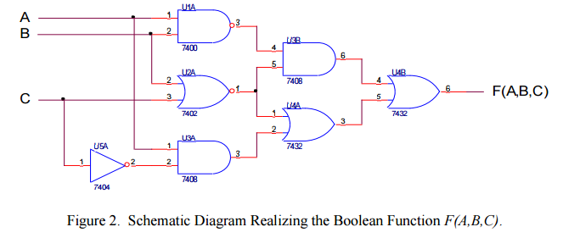

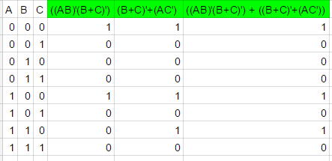The figure above was used as a wiring guide for the Logic chips, also a truth table and algebraic formula was derived by hand by inspection of the figure. Below is the finale part of the of truth table.

Then the actual experiment was run to see if the predicted results matched the actual results.

Discussion of Results:

1. Experiment 1:
2. For each of the three logical operations, how does the truth-table derived from the TTL logic gate compare with the truth-table derived from the corresponding abstract logical function? Does the TTL logic gate accurately implement the abstract logical function?

The derived and the actual results matched exactly, the Logic gates does accurately implement the abstract logical function

II. Experiment 2:

1. Compare the truth-table you derived manually from the schematic diagram with the truth-table that you derived from the hardware implementation.

|  |
| --- |
| 1 |
| 0 |
| 0 |
| 0 |
| 1 |
| 0 |
| 1 |
| 0 |

Derived vs Actual result



III. Conclusions:

1. Discuss how SN7400 family TTL logic gates can be used to implement abstract Boolean functions.

The SN74 -08, -32 are the AND and OR gates, in Boolean algebra they stand for * and +. Their opposites are the SN74 -00, -02 which are the NAND and NOR gates. The hex invertor will turn into input into a output, which is the compliment.

1. Discuss how the ELENCO Digital Analog Trainer kit is used to build and test a hardware implementation of an abstract Boolean function.

The ELENCO Digital Analog Trainer kit was used as a power source for the breadboard on the kit the power lines on the breadboard then powered each chip so they can perform their function. And input source was connected using a wire connecting the logic gates on the kit to the breadboard row containing the input point.

NAND gate

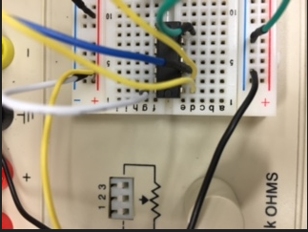

OR gate

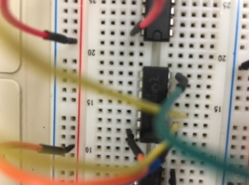

NOR gate

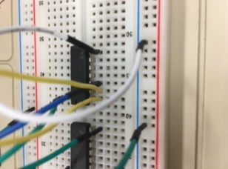

F(A,B,C) =

